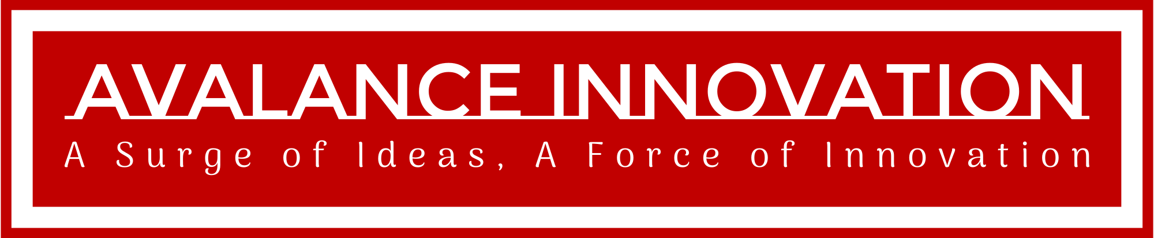

**Avalanche Innovation Team:**

Nishan Subba - Database Administrator

Aman Gurung - Data/Business Analyst I

Chiagoziem Igwe - Data/Business Analyst II

Dhulfiqar Hussein - Lead Developer I, Full Stack

Harshitha Sayini - Developer II, Full Stack

Trevin Nisbett - Project Manager, Quality Assurance

Professor: Shiva Sharma - IS436 Structured Systems Analysis and Design

Date: Oct 20, 2023

Deliverable Name: Project Deliverable 2 - Requirements Definition Document and Use Cases

# Requirements Definition Document and Use Cases for Gorilla Distribution Center's Payroll Modernization

**Requirements Definition Document and Use Cases for Gorilla Distribution Center's Payroll Modernization 2**

Functional Requirements 4

➢ Processed Oriented 4

➢ Information Oriented 4

Nonfunctional Requirements 4

➢ Operational 4

➢ Performance 4

➢ Security 5

➢ Cultural/political 5

**Interviews 5**

Interview #1: John Jackson, HR Department Manager 5

Purpose of the Interview 5

Summary of the Interview 5

Full Interview Transcript 6

Observation Notes 8

Follow Up Questionnaire 8

Conclusion 13

Interview #2: Robert Cohen, Legal/Compliance Officer 13

Purpose of the Interview 14

Summary of the Interview 14

Full Interview Transcript 14

Observation Notes 16

Questionnaire 16

Interview #3: Luna Hernandez, Line Manager 17

Purpose of the Interview 17

Summary of the Interview 17

Full Interview Transcript 17

Observation Notes 19

Questionnaire 19

Interview #4: Max Wattson, Regular Employee 20

Purpose of the Interview 20

Summary of the Interview 20

Full Interview Transcript 20

Observation Notes 22

Follow Up Questionnaire 22

Conclusion 26

Interview #5: Mr. Fred Jones, CEO and Founder 26

Purpose of the Interview 26

Summary of the Interview 26

Full Interview Transcript 27

Observation Notes 29

Questionnaire 29

Interview #6: Melissa May, Software Developer 29

Purpose of the Interview 29

Summary of the Interview 29

Full Interview Transcript 29

Observation Notes 31

Questionnaire 31

Interview #7: Mark Thomas, IT Manager 31

Purpose of the Interview 31

Summary of the Interview 31

Full Interview Transcript 31

Observation Notes 32

Questionnaire 33

List of Questions 33

General Introduction and General Question 33

Current System and Challenges 33

Legal and Compliance 33

Collaboration within Department 34

Data Security 34

Employee Interaction and Feedback 34

Future Expectations and Features 35

**Use Case 35**

List of Use All Cases 35

Use Case Documentation and Diagram 37

Use Case 1: Process Payroll 37

Use Case 2: Add Employee 38

Use Case 3: Generate Payroll Report 40

Use Case 4: Deductions and Benefits Calculation 42

Use Case 5: Employee Self-Service 43

Use Case 6: Overtime Approval 45

**Document Used/Referenced 47**

## Functional Requirements

### Processed Oriented

* The system should allow employees to review their payment history for the last 2 years.
* The system should allow for constant feedback from employees.
* The system should have proper expense management and processing.
* The system should allow employees to request services. (E.g., customer service)

### Information Oriented

* The system must include an inventory of all employees.
* The system should have a dashboard that allows employees to navigate throughout the system.
* The system should have time and attendance management for employees.
* The system must be able to save employees’ information for at least 3 years.

## Nonfunctional Requirements

### Operational

* The system should be able to run on both mobile and computer devices.
* The system should be able to integrate with existing systems if necessary.
* The system should be accessible from any web browser.

### Performance

* The interaction and communication between the system and employees should be quick.
* The system should be available to employees 24 hours a day all year round.
* The system should be able to support all employees at once without any delays or lags.

### Security

* Only authorized personnel such as direct managers can view employee records.
* The system must include proper safeguards to protect from viruses, worms, and hackers.

### **Cultural/political**

* Private and personal information is protected by the Data Protection Act.

# Interviews

In order to gain the company's insight, we conducted various interviews from various positions to get their perspectives. We want to know what are the current challenges and future expectations of the new digital payroll system.

## Interview #1: John Jackson, HR Department Manager

Name of Interviewee: John Jackson

Position of Interviewee: HR Department Manager

Date and Time of Interview: Oct 19, 2023, 11:00 AM

Name of Interviewer: Nishan Subba, Database Administrator

Method of Interview: On-Site, In-Person

### Purpose of the Interview

The primary purpose of this interview was to understand the current challenges and inefficiencies faced by the HR department, especially concerning the payroll process. The insights gained from this interview would serve as a foundation for designing a robust and efficient digital payroll system tailored to the company's specific needs.

### Summary of the Interview

John Jackson highlighted several critical issues with the current manual payroll system. The primary concerns revolved around the time-consuming manual entry of timecards, lack of real-time updates, and challenges faced during tax season. John emphasized the need for enhanced data security, analytics capabilities, and better integration with existing systems. The transition to a digital payroll system is viewed positively, but there are concerns regarding the learning curve and potential disruptions to the current payroll cycle.

### Full Interview Transcript

|  |  |
| --- | --- |
| Questions | Comments/Answer |
| Can you introduce yourself, and what do you do? | Hello, I'm John Jackson, the HR Manager here at Gorilla Distribution Center. I've been with the company for over seven years and in my current role for the past three. As the HR Manager, I oversee the entire HR department, ensuring that all HR functions, from recruitment and onboarding to payroll and employee relations, run smoothly. |
| Could you provide an overview of the current payroll process? | Our payroll process begins with manual timecard submissions from various departments. These timecards are collected, verified, and manually entered into our database. Once all the data is entered, our team calculates the pay, considering overtime, bonuses, and deductions. This process takes about a week. Following this, checks are processed and any discrepancies reported afterward are addressed in the next payroll cycle. |
| Do you have any pain points or challenges in the current payroll system? | The biggest pain point is manually entering timecards which is very time-consuming and prone to a lot of errors and discrepancies. Also, the lack of automated checks means discrepancies often go unnoticed until they're reported by employees. The system also doesn't cater to real-time updates or changes, making last-minute adjustments very challenging. |
| How does the HR team handle employee leaves, bonuses, and overtime? | Everything is handled manually. For leaves, we refer to leave applications and adjust the payroll accordingly. For a bonus and overtime, department heads handle that and they will let us know so we can incorporate them into the payroll. |
| How often do you have to work with other departments regarding payroll, and what are those interactions typically about? | Almost daily. We frequently interact with department heads regarding bonuses, overtime approvals, or discrepancies in time logs. We also regularly coordinate with the finance department for fund approvals and disbursement. |
| Data security is important everywhere, what measures are currently in place, and what are your expectations from the new system? | Currently, our data is stored in a local server with limited access controls. I know data security is very important and I hope that with this new system, we get more data security measures. |
| How do you handle payroll-related questions from employees? | Employees usually approach the HR desk with their questions. We then reference the manual logs and resolve their concerns. This is a very slow process, we don't want to find out about errors and discrepancies after the payroll cycle, we want to find out before the payroll cycle so we can fix it. |
| Are there any additional features or tools you believe would aid the HR team in payroll management? | An analytics dashboard would be helpful. It would allow us to view trends, such as overtime hours across departments, and provide insights into payroll components. A notification system alerting us to any discrepancies or anomalies in real time would also be invaluable. |
| How do you determine raises and bonuses for an employee? | We do an annual employee performance review and from that result, bonuses or raises are decided. Then, we manually put that data into the payroll for the next payroll cycle. |
| What challenges do you face during tax season in terms of payroll and employee documentation? | During tax season, we often receive numerous requests from employees for tax-related documents. Not to mention that adjusting for accurate tax deductions due to changing tax brackets becomes challenging with our current manual approach |
| How does the HR team stay updated on regulatory changes that impact payroll? | We rely on updates from our legal team. However, manually updating these changes in our current system is a labor-intensive task. |
| Is there any software or tools you wish to integrate with the new system? | Integrating with our existing employee management system and financial accounting software would be good to avoid manual data entry. |
| How do you currently manage records for past employees, and what would you expect from the new system in this regard? | Past employee data is archived in physical files and a local server. From the new system, we'd expect an efficient digital archiving method that allows easy retrieval of past records when needed. |
| How does the HR department handle overtime approvals, and how would you envision this process in the new system? | Currently, our overtime approvals are managed through paper forms signed by their respective department head. With the new system, I hope it will have a seamless approval system instead of going through the department head. We want employees to have easier access to overtime. |
| Are there any concerns or reservations you have about transitioning from the current manual system to a digital payroll solution? | While we understand the benefits, there's a concern about the learning curve for our team and ensuring that the transition is smooth without disruptions to the payroll cycles. |

### Observation Notes

* The HR team seems to be overwhelmed by the manual processes, which leaves room for errors and delays.
* The current system lacks real-time tracking and alerts, causing discrepancies to be identified late, often by employees themselves.
* There's a clear disconnect between various departments, requiring frequent back-and-forths.
* The physical archiving of past employee data suggests that there might be a significant backlog of digital data entry waiting.
* Overtime approval seems to be a bottleneck

### Follow Up Questionnaire

After the interview, we made a follow-up questionnaire and sent it to all HR team members through Google Forms.

Questionnaire Distributed To HR Team (15 members)

Date Distributed: Oct 20, 2023

Method of Distribution: Emailed Google Forms

Response Deadline: November 20, 2023

Response Rate: 13 out of 15 members have responded (87% response rate)

HR Team Payroll System Questionnaire Response Rate:

How satisfied are you with the current payroll system?

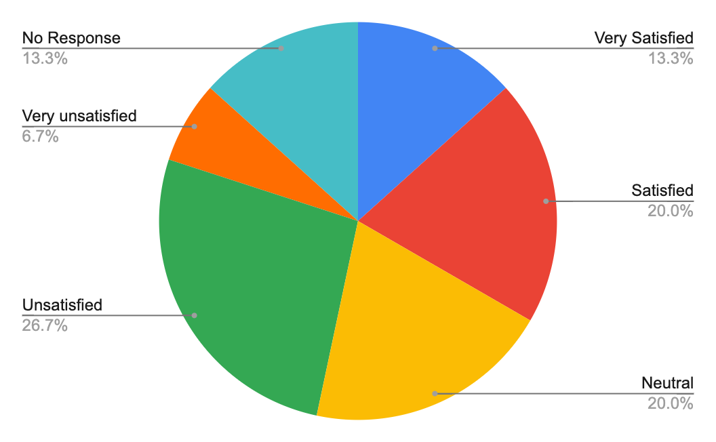

How would you rate the accuracy of the current payroll system?

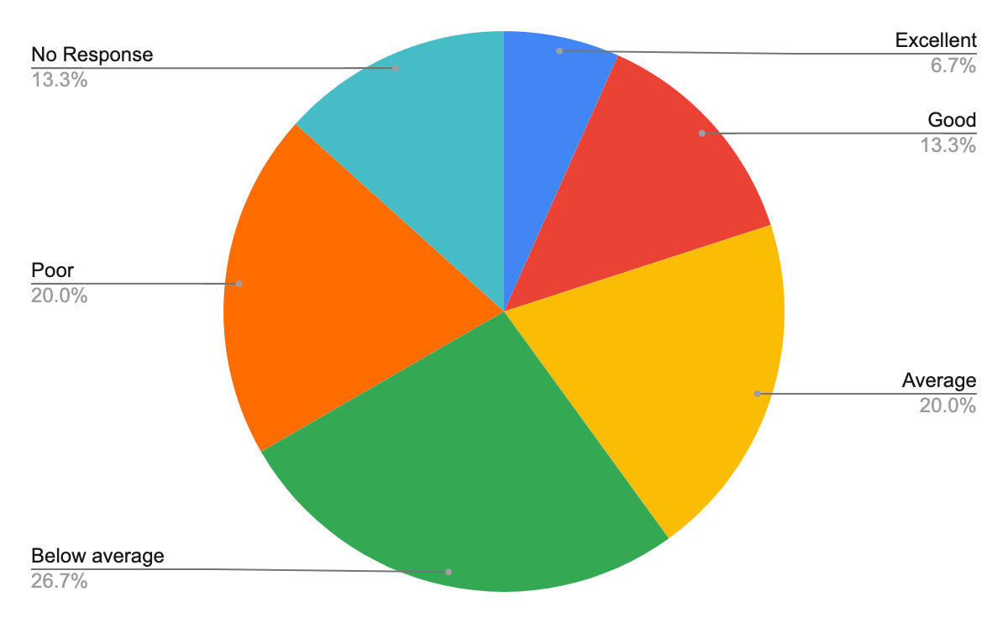

How user-friendly do you find the current payroll system?

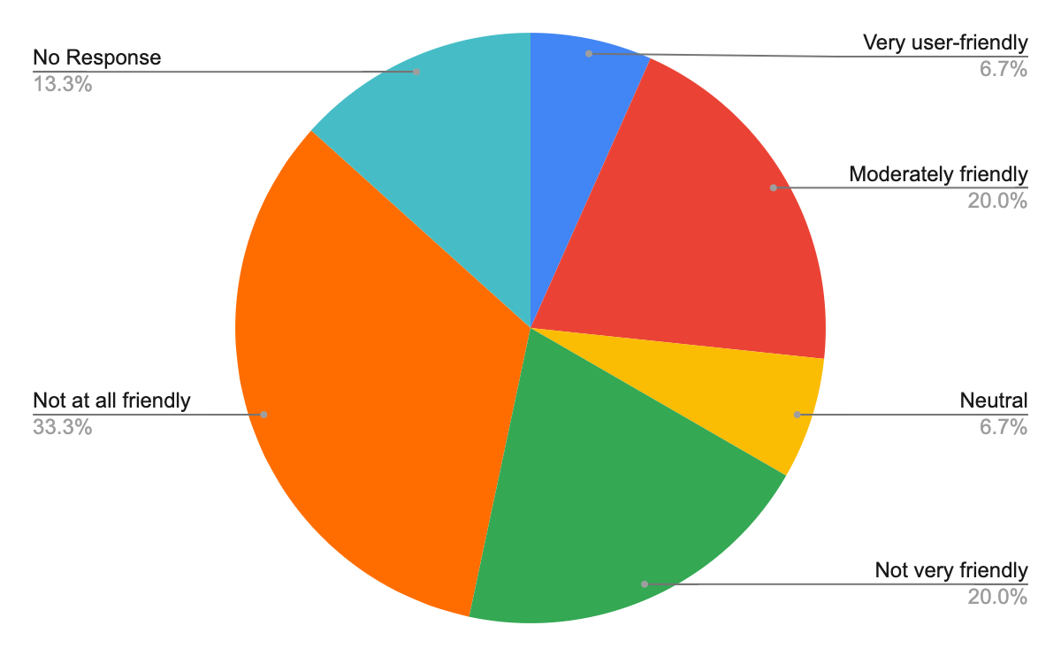

How frequently do you encounter errors or issues with the current payroll system?

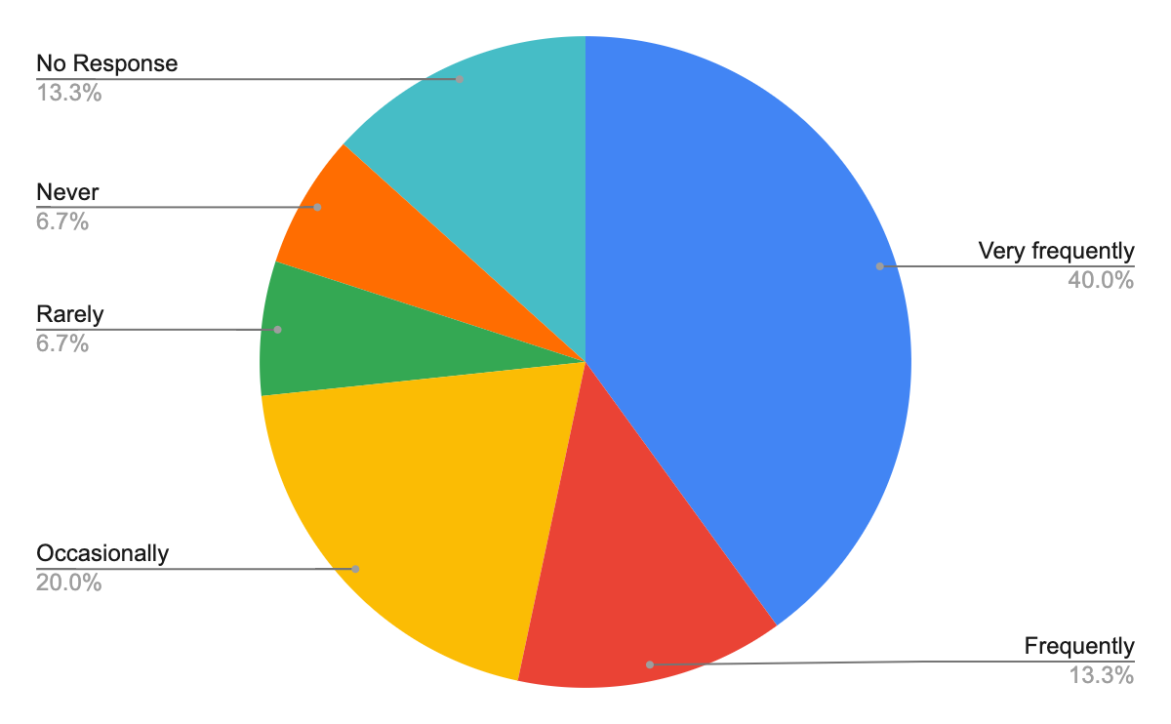

How important is integration with other HR tools and systems for the new payroll system?

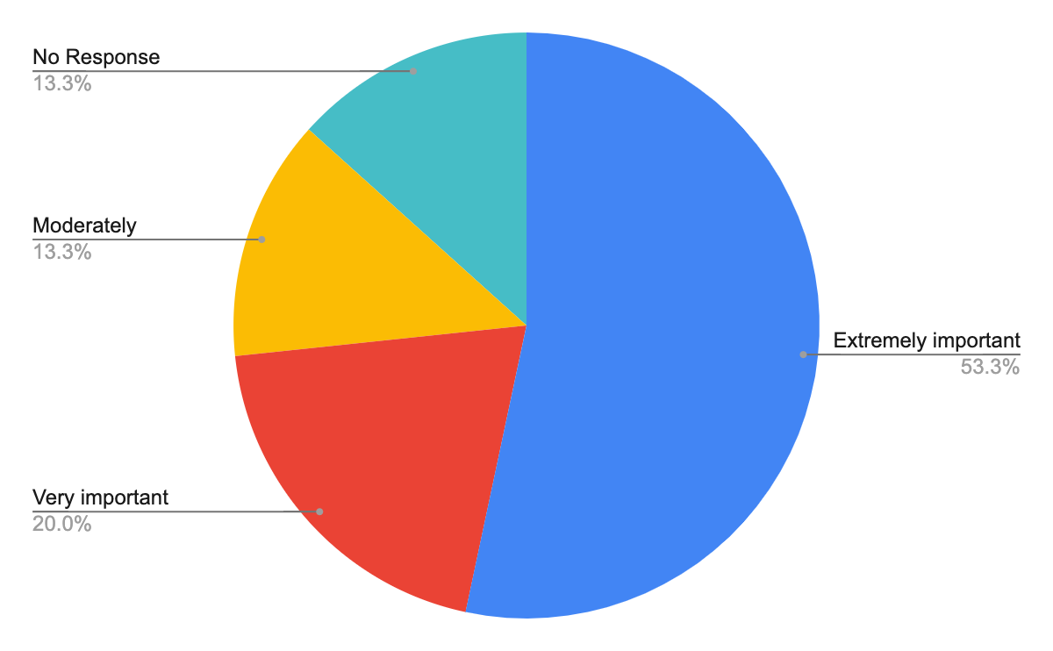

How do you prioritize data security in the new payroll system?

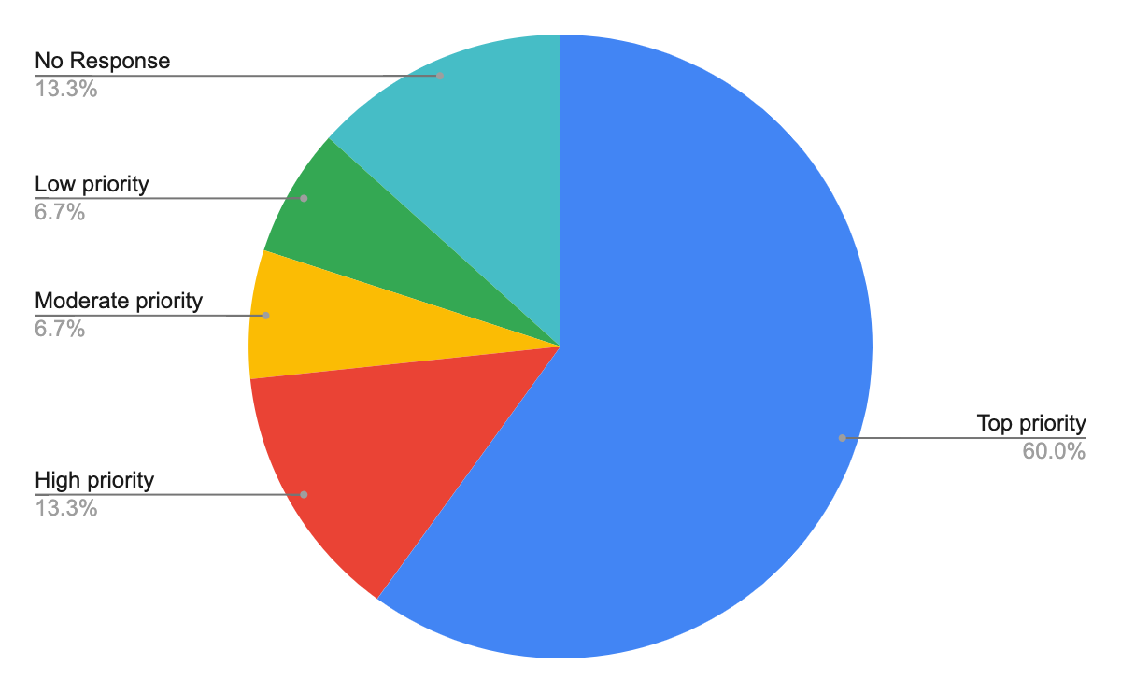

Would you prefer a cloud-based or on-premises payroll system?

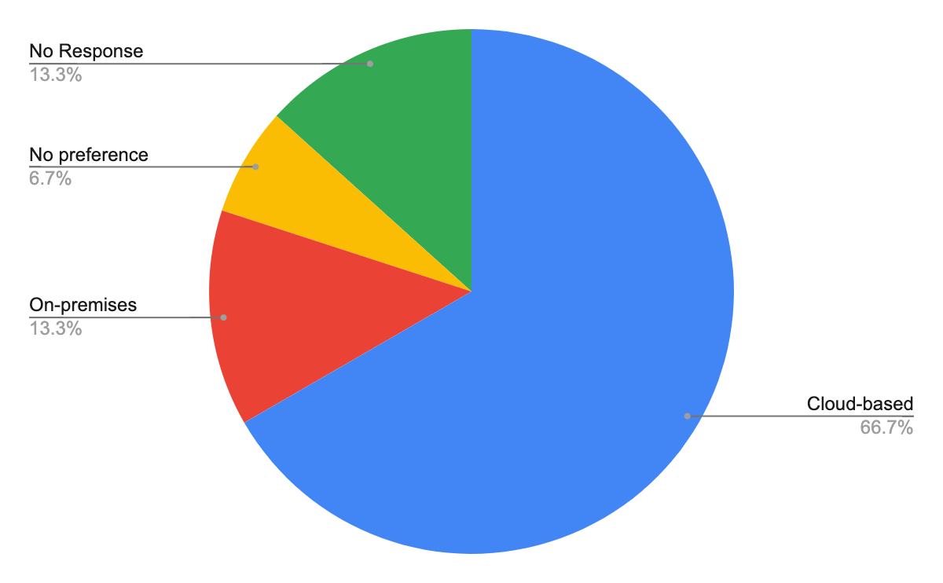

How important is the mobile accessibility of the payroll system to you?

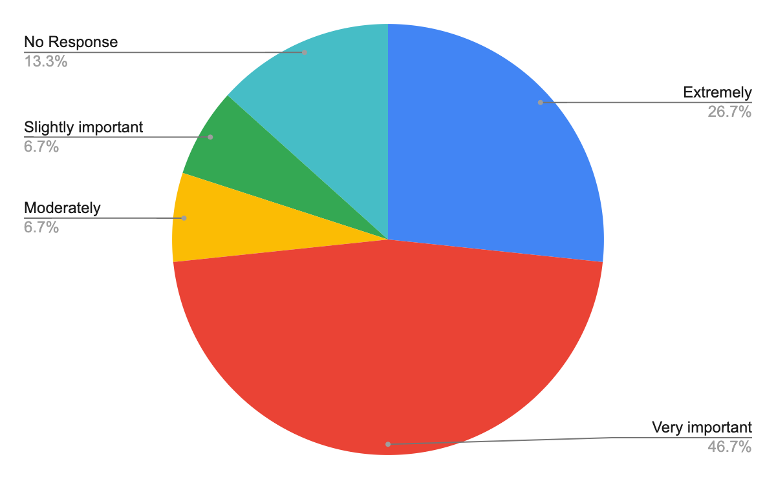

What is your preferred method for supporting or troubleshooting the payroll system?

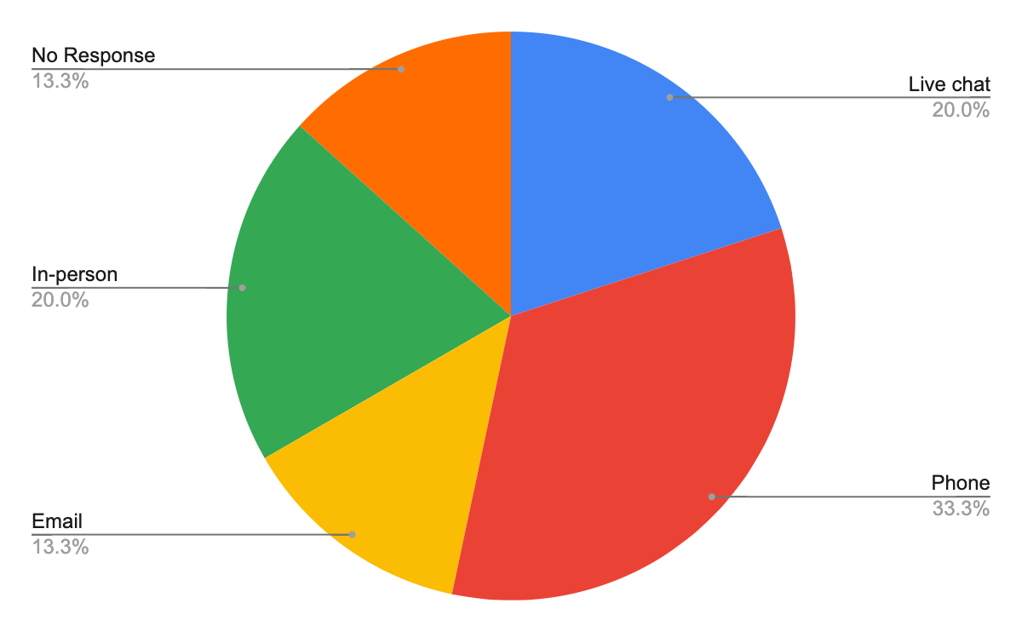

How would you rate the importance of having advanced analytics and reporting features in the new payroll system?

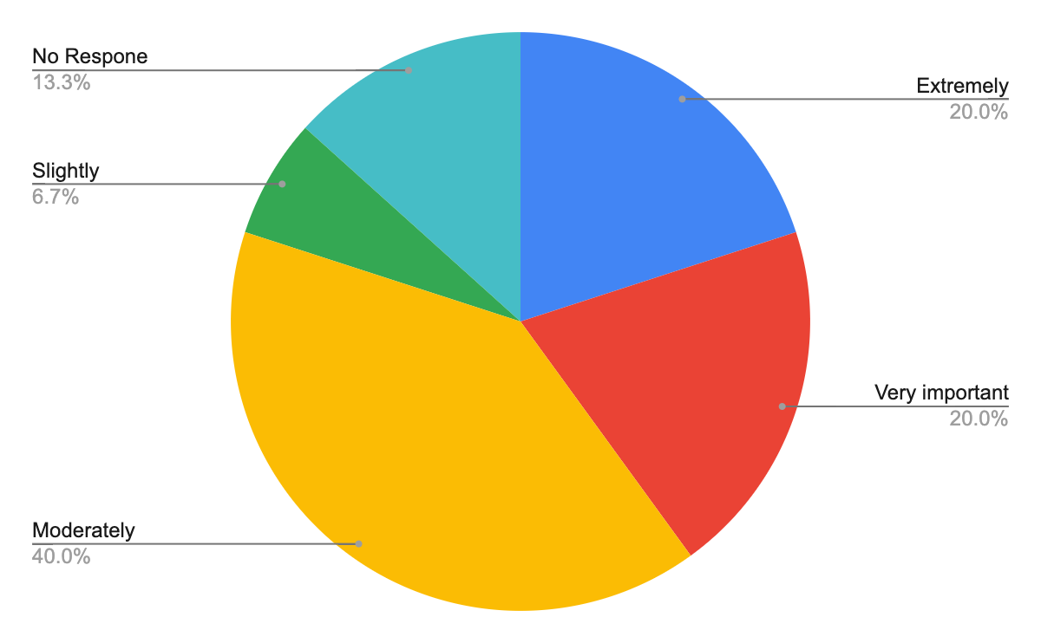

### Conclusion

Overall, the survey indicates a clear need for a revamped payroll system that is accurate, user-friendly, integrated, and secure. The preferences lean toward a cloud-based system with mobile accessibility. Advanced analytics and reporting features are also seen as beneficial additions.

## Interview #2: Robert Cohen, Legal/Compliance Officer

Name of Interviewee: Robert Cohen

Position of Interviewee: Legal/Compliance Officer

Date and Time of Interview: October 29, 2023, 2:00 PM

Name of Interviewer: Nishan Subba, Database Administrator

Method of Interview: On-Site, In-Person

### Purpose of the Interview

The primary objective of this interview was to gather insights on the legal and compliance aspects of the current payroll system. By understanding the challenges and requirements from a legal standpoint, we can ensure that the new system is not only efficient but also adheres to all regulatory standards.

### Summary of the Interview

Robert Cohen highlighted the importance of staying updated with regulatory changes and ensuring that the payroll system remains compliant. Some of the key challenges he mentioned include frequent changes in labor laws, ensuring accurate tax deductions, and data privacy concerns. He highlighted significant concerns regarding data security when transitioning to a digital system.

### Full Interview Transcript

|  |  |
| --- | --- |
| Question | Comments/Answer |
| Can you briefly describe your role and responsibilities when it comes to the company's payroll system? | Hello, I'm Robert Cohen, the Legal/Compliance Officer here at Gorilla Distribution Center. I've been with the company for over ten years, ensuring that our operations and business practices align with legal standards and industry regulations. As the Legal/Compliance Officer, I ensure that our payroll system adheres to all legal and regulatory standards. This includes monitoring changes in labor laws, tax rates, and other relevant statutes, and ensuring our system remains compliant. |
| What are the most common legal or compliance challenges you face concerning payroll? | The frequent changes in labor laws, especially regarding overtime and benefits, pose significant challenges. Also, ensuring accurate tax deductions and remaining compliant with data privacy regulations are also my concerns. |
| Are there any specific legal or compliance considerations we should be aware of in the new payroll system? | The new system should have the capability to automatically update based on regulatory changes. It should also be very safe so that only certain individuals have access to certain data. It is our number one priority. |
| How do you currently stay updated on regulatory changes that impact payroll? | I subscribe to legal news, collaborate with my industry peers, and attend relevant workshops. It's crucial for our company to remain proactive rather than reactive to these changes. |
| In terms of documentation and record-keeping, what are the compliance requirements we need to be aware of? | We must retain payroll records for a minimum of seven years as per local regulations. This includes salary slips, tax deduction documents, overtime calculations, and other related paperwork. |
| How do you handle potential disputes or legal challenges related to payroll? | We first aim to internally resolve any disputes through dialogue with the concerned parties. If unresolved, we have a set protocol to escalate the matter, working closely with our legal team. |
| Do you foresee any potential risks or challenges in transitioning from the current manual system to a digital solution? | While digital solutions offer efficiency, there's a risk of data breaches. Ensuring top-notch security features and regular audits will be crucial in order to have a successful transition. |
| What kind of reporting or auditing features would be beneficial from a legal/compliance perspective in the new system? | Regular compliance audits and alert systems for potential breaches or non-compliance incidents would be invaluable. |
| How does the company currently handle international payroll, if applicable, and what are the associated compliance challenges? | We currently do not have anyone working internationally. |
| Are there any other departments or teams you collaborate with regarding payroll compliance? | Yes, I work closely with the HR and Finance departments. Their input is invaluable in ensuring that our payroll processes are both efficient and compliant. |
| From a legal standpoint, what considerations should be taken into account for data backups and disaster recovery for the payroll system? | Regular and encrypted backups are essential. In case of any data loss, we must have a disaster recovery plan to ensure data integrity and availability. |
| How do you handle data requests, whether from governmental bodies or employees, regarding payroll? | All requests undergo a thorough verifying process to ensure legitimacy. Once verified, the data is shared in a secure and compliant manner. |
| What is your expectation from the new payroll system in terms of legal and compliance features? | My expectation is that the system is adaptive and secure. It should not only meet current compliance standards but also be equipped to adapt to future regulatory changes. |

### Observation Notes

* The current manual system poses challenges in staying updated with frequent regulatory changes.
* There's a strong emphasis on data security
* The company doesn't currently handle international payroll,
* Regular audits and checks seem to be lacking in the current system, pointing to a potential area of improvement in the new digital system.
* The legal team wants to make sure that they are always ahead of the legal changes and compliance, but the manual nature of the current system seems to hinder efficiency.
* There's a clear need for a system that not only meets the current compliance standards but is also adaptive to future changes.

### Questionnaire

No further questionnaire was sent out to the legal team.

## Interview #3: Luna Hernandez, Line Manager

Name of Interviewee: Luna Hernandez

Position of Interviewee: Line Manager, Production Department

Date and Time of Interview: October 25, 2023, 10:00 AM

Name of Interviewer: Nishan Subba, Database Administrator

Method of Interview: On-Site, In-Person

### Purpose of the Interview

The primary aim of this interview was to understand the challenges and needs related to the payroll system from the perspective of a line manager overseeing the Production Department. Luna Hernandez's insights will provide valuable input to ensure that the new system addresses the specific concerns of line managers and facilitates smoother operations since they are involved in day-to-day operations.

### Summary of the Interview

Luna Hernandez highlighted the significant time and effort required with the current manual payroll system. The challenges include manual overtime calculations, lack of transparency when reporting discrepancies, and the tedious task of validating hours and approving overtime. There is a clear need for a more streamlined and automated system that provides a dashboard for easy monitoring, and automated error checks. While there are concerns about the learning curve associated with transitioning to a digital system, the overall sentiment is positive, provided there are adequate training and resources.

### Full Interview Transcript

|  |  |
| --- | --- |
| Question | Comments/Answer |
| Can you describe how the current payroll system impacts your day-to-day operations and responsibilities? | Hello, I'm Luna Hernandez and I'm currently working as a Line Manager for the Production Department. The current manual system requires a significant amount of time. I often find myself double-checking hours, overtime calculations, and other data entries, which takes time away from my primary responsibilities which is to ensure that we complete our daily required tasks. |
| How do you currently report or communicate any payroll discrepancies or errors? | I usually email the HR department. However, this process lacks transparency, and it's sometimes hard to track the status of reported issues. |
| What features or improvements would you like to see in the new payroll system from a line manager's perspective? | A dashboard for easy monitoring and reporting would be really good, and automated error checks and a clear communication channel with HR would be ideal. |
| How often do you interact with the payroll system, and for what specific tasks? | I interact with it bi-weekly to validate hours, approve overtime, and address any discrepancies that arise. |
| Do you face challenges in managing overtime, leave, or other specific payroll-related tasks? | Yes, especially with overtime. It's tedious to manually calculate and sometimes results in errors. |
| How do you currently track and manage your team's attendance and time worked? | We use a manual punch card system, which I then have to cross-verify and enter into the payroll system. |
| From a line manager's perspective, what challenges do you foresee in transitioning from the current system to a digital one? | There might be a learning curve for some managers, especially those not tech-savvy. However, with proper training, I believe we can overcome this. |
| Are there any specific training or resources you'd like to see provided to help with the transition? | A hands-on training session would be great, along with a detailed user manual and a dedicated helpline for any issues. |
| How do you handle team members' questions or concerns related to their pay? | I usually direct them to HR. However, it would be beneficial if I had access to some basic information to address minor questions on the spot. |
| In terms of reporting, what kind of insights or data would be helpful for you from the payroll system? | A breakdown of hours worked, overtime, and leave taken. This would help us have an easier time managing overtime accessibility. |
| Do you work with any other departments regarding payroll? If so, which ones and how? | Mostly with HR for discrepancies and questions. |
| How do you currently handle new hires or departures in relation to the payroll system? | I inform HR, who then makes the necessary updates. |
| Are there any specific concerns or issues your team members have raised about the current payroll system that we should be aware of? What do you hope to get from the new digital system? | The main concerns are related to delayed payments, errors in overtime calculations, and lack of transparency. My hope is that this new digital system fixes a lot of errors we get when calculating pay. |

### Observation Notes

* The current manual payroll system is time-consuming and requires cross-verification, taking time away from primary managerial responsibilities.
* Manual calculations, especially for overtime, are prone to errors, leading to dissatisfaction among team members.
* The use of a manual punch card system for tracking attendance is outdated and can benefit from digitalization.
* Some are concerned about the learning curve, especially among those who may not be familiar with technology.
* There's a clear demand for hands-on training for the new system
* The digital system will solve a lot of problems she mentioned like errors in the calculator and discrepancies

### Questionnaire

No further questionnaire was sent.

## Interview #4: Max Wattson, Regular Employee

Name of Interviewee: Max Wattson

Position of Interviewee: Production Technician

Date and Time of Interview: October 26, 2023, 10:00 AM

Name of Interviewer: Nishan Subba, Database Administrator

Method of Interview: On-Site, In-Person

### Purpose of the Interview

The objective of this interview with Max Wattson was to understand the experiences and challenges faced by regular employees in relation to the current payroll system. As the system primarily serves these employees, their feedback is essential for its improvement.

### Summary of the Interview

Max Wattson expressed concerns regarding the current manual payroll system. He highlighted errors in overtime calculations and faced delays in receiving salaries, which caused financial inconveniences. The punch card system used for attendance tracking sometimes malfunctions, leading to discrepancies. While Max is open to transitioning to a digital platform, he highlighted the importance of a user-friendly interface, and security features like two-factor authentication. He rates his satisfaction with the current system as average.

### Full Interview Transcript

|  |  |
| --- | --- |
| Question | Comments/Answer |
| Please introduce yourself and what do you do? | Hello, I'm a Product Technician here at Gorilla Distribution Center. I work 9-5. |
| How often do you interact with the current payroll system, and for what specific tasks? | Mostly to check my monthly pay slip and occasionally to apply for leave. |
| Have you encountered any discrepancies in your pay? | Yes, a few times. There were errors in overtime calculations, and once my bonus was not reflected in the pay. |
| How do you currently report or address any payroll-related concerns? | I usually approach my line manager, who then communicates with HR. |
| From your perspective, what features or improvements would you like to see in the new payroll system? | A user-friendly interface to view pay details, apply for leaves, and a feature to raise any payroll discrepancies directly. |
| How do you feel about the current method of recording attendance and its accuracy? | We use a punch card system, and sometimes it fails to register, leading to discrepancies in attendance records. |
| Would you be open to using a mobile or web application for payroll-related tasks? Why or why not? | Absolutely, it would be much more convenient. |
| What kind of training or support would you prefer to help transition to a new digital payroll system? | An interactive tutorial video would be helpful or even an infographic |
| Have you ever faced delays in receiving your salary or benefits? How did it impact you? | Yes, there was a delay once due to some system issues. It caused financial stress as I had bills to pay. |
| What's your opinion on the transparency and clarity of the current pay slips and payroll information provided to you? | It's quite basic. I'd appreciate a more detailed breakdown, especially regarding deductions and benefits. |
| How would you rate your overall satisfaction with the current payroll system on a scale of 1 to 10, with 10 being the highest? | I'd give it a 5. It serves its purpose, but there's a lot of room for improvement. |
| Do you discuss payroll-related matters with your colleagues? If so, what are common concerns or suggestions? | Yes, sometimes. Common concerns are around errors in pay, delay in salary, and lack of clarity on deductions. |
| What kind of security feature would you like to see? | Definitely two-factor authentication. |

### Observation Notes

* The current manual system seems to have frequent errors
* The punch card system for attendance is outdated and prone to malfunctions
* Employees seem open to transitioning to a digital platform, provided it offers a user-friendly experience.
* There's a clear demand for more transparency in the pay details
* Delays in pay due to system issues have caused financial inconveniences for employees.
* Employees discuss payroll matters among themselves, which shows that concerns are widespread.
* Employees emphasize the need for better security features

### Follow Up Questionnaire

After the interview, we made a follow-up questionnaire and sent it to all regular employees through Google Forms.

Questionnaire Distributed To Regular Employee: (500 Employee)

Date Distributed: Oct 27, 2023

Method of Distribution: Emailed Google Forms

Response Deadline: November 20, 2023

Response Rate: 375 out of 500. (75% Response Rate)

Regular Employee Payroll System Questionnaire Response Rate:

How often do you interact with the current payroll system?

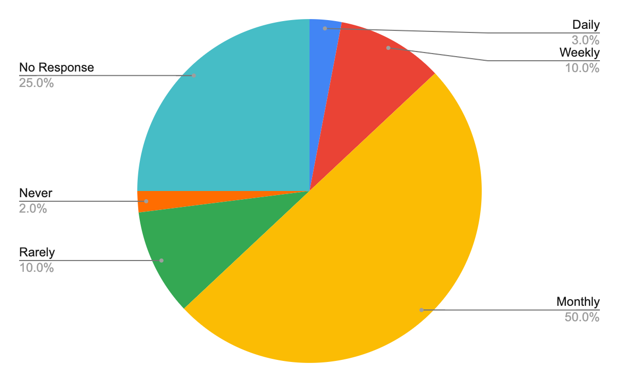

Have you ever faced discrepancies in your pay using the current system?

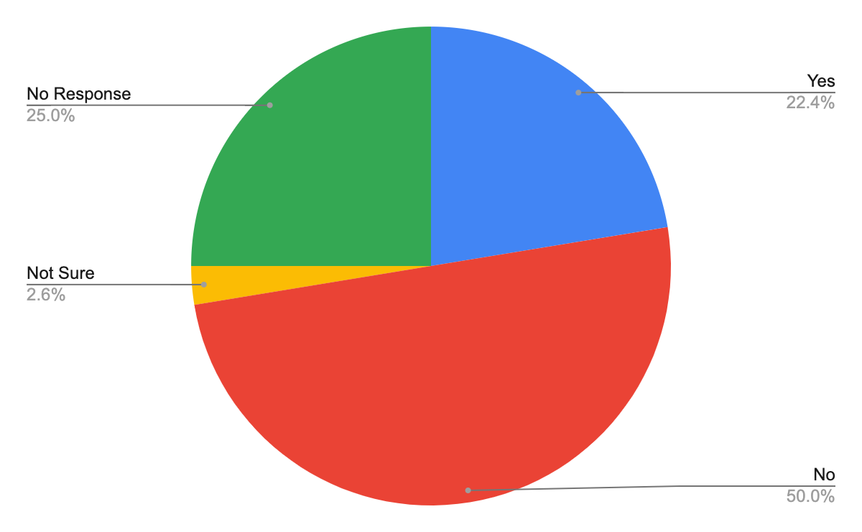

How easy or difficult is it to understand your pay slip details?

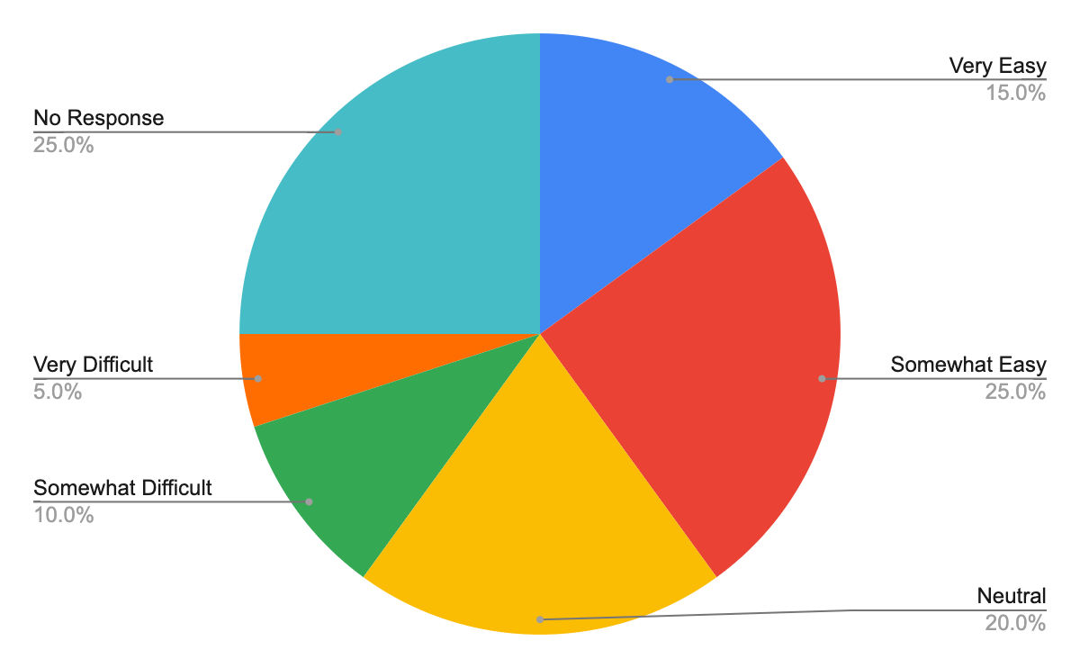

Would you prefer a mobile or web application for payroll-related tasks?

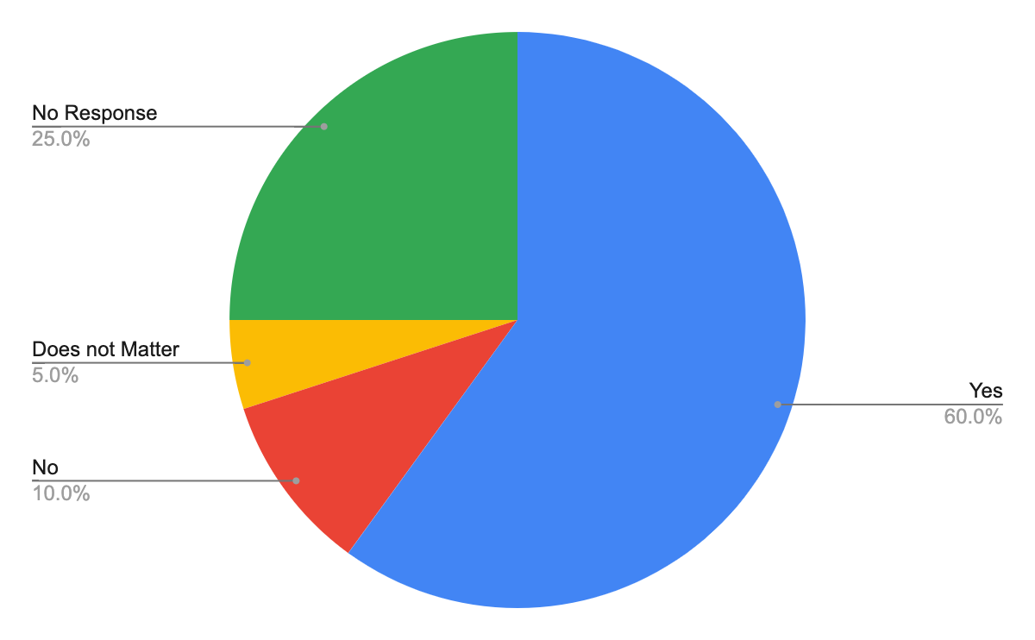

How satisfied are you with the current method of reporting payroll-related concerns?

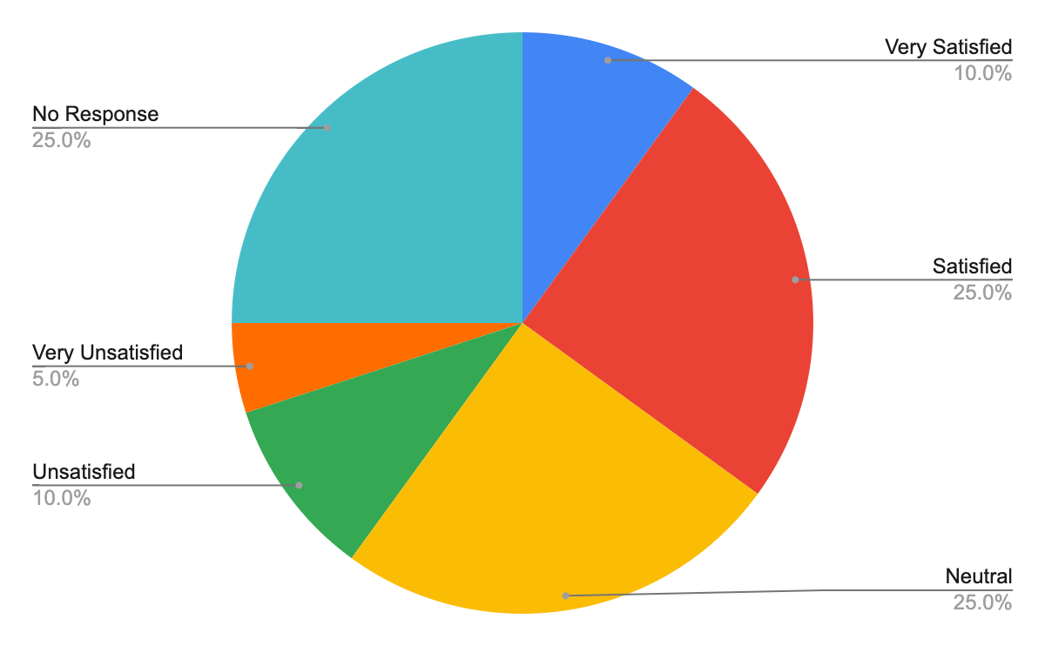

Have you ever faced delays in receiving your salary?

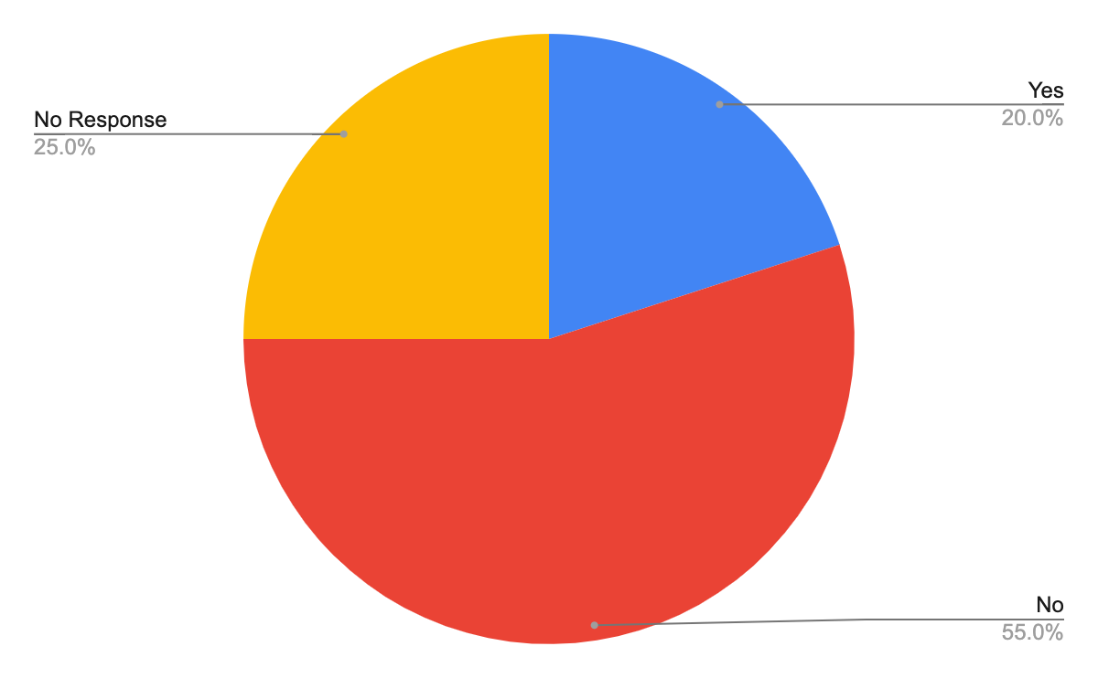

Would you feel more secure with a two-factor authentication feature in the new payroll system?

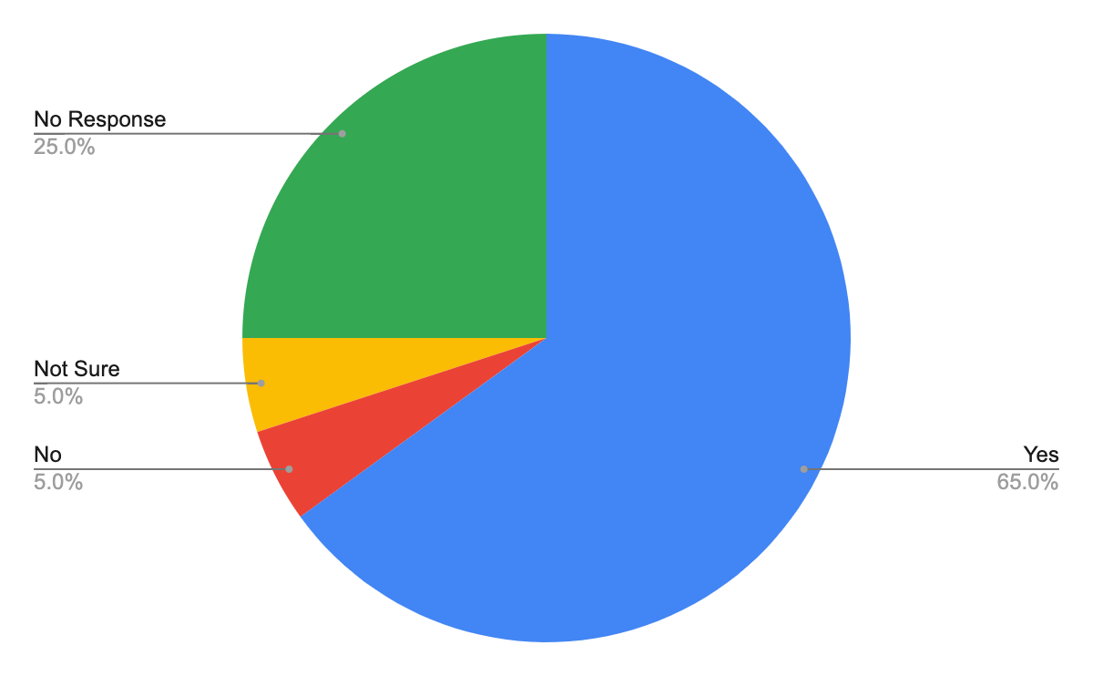

### Conclusion

* Most employees interact with the payroll system monthly and would prefer a mobile or web application for easier access.
* About 22% have experienced discrepancies in their pay, and a similar percentage have faced salary delays.
* There's a notable demand for clearer pay slip details
* A significant majority value security features like two-factor authentication.

## Interview #5: Mr. Fred Jones, CEO and Founder

Name of Interviewee: Mr. Fred Jones

Position of Interviewee: CEO and Founder

Date and Time of Interview: Nov 1, 2023, 10:00 AM

Name of Interviewer: Nishan Subba, Database Administrator

Method of Interview: Video Conference Meeting

### Purpose of the Interview

To gain insights from Mr. Jones, regarding the current challenges of the payroll system, understand the expectation of the new payroll system with the company's strategic goals, and to gather leadership's expectations and requirements for digital transition.

### Summary of the Interview

Mr. Jones highlighted the company's commitment to transparency, efficiency, and employee well-being. He acknowledged the existing challenges in the current payroll system and expressed optimism about the potential of a new digital payroll system to address these issues. He highlighted the need for the system to offer value for money, stressing a positive return on investment. Integration with other company systems and scalability for future growth were crucial. Data security, compliance, and user experience were some of the primary concerns.

### Full Interview Transcript

|  |  |
| --- | --- |
| Question | Comments/Answer |
| Mr. Jones, can you introduce yourself and about the Gorilla Distribution Center? | Hello, Mr. Jones, the CEO and founder of Gorilla Distribution Center. I started this company with a vision to revolutionize the distribution industry. Over the years, we've grown significantly and established ourselves as a market leader in our field. Our goal is to always achieve excellence in our field. Gorilla Distribution Center is not just a business for me; it's a passion and a testament to the hard work and dedication of our incredible team. Our focus remains on delivering the best service to our clients while also ensuring the well-being and growth of our employees. |
| Mr. Jones, what are the strategic goals of your company? | At Gorilla Distribution Center, our goals are transparency, efficiency, and the well-being of our employees. We are committed to maintaining transparency in all our operations. Efficiency in our distribution processes is vital, as it not only enhances our service quality but also drives growth. Lastly, we believe that the foundation of our success lies in the well-being and development of our employees. |
| How do you think the new digital payroll system helps achieve Gorilla Distribution Center's strategic goals? | The new digital payroll system is not just about bringing convenience to our employees; it's a reflection of our commitment to transparency, efficiency, and respect for our workforce. |
| Are there any specific pain points or challenges you've identified in the current payroll system from a leadership perspective? | Yes, I've been informed of occasional inaccuracies and delays, which tarnish our reputation and impact employee morale. We need a system that's reliable and accurate. |
| From a budgetary standpoint, are there specific constraints or expectations for the new payroll system? | While we're committed to investing in a robust system, we must ensure we get value for money. Return on Investment (ROI) is crucial. We're not just looking for features but for tangible benefits. However, we would like to implement this feature under $5 million dollars. I know we would have to invest a lot upfront; however, we hope to get a positive return in our investment. |
| What is your view on integration of the payroll system with other company systems? | Integration is key. We don't want isolated systems but a cohesive ecosystem that boosts overall productivity. |
| Are there any strategic goals or future plans that the new payroll system should be prepared to support? | We're looking at expanding our workforce, so the system should be scalable and adaptable for our future growth. |
| What kind of feedback or reports would you like to receive from the payroll system to aid in decision-making? | I'd really like detailed analytics and dashboard on payroll expenses, trends, anomalies, and projections. Information that can help make informed business decisions especially dealing with investment. |
| How do you prioritize user-friendliness, security, and scalability for the new system? | While all are vital to our success, I'd prioritize security and scalability. However, we shouldn't compromise on user experience. It's a delicate balance. We must ensure that the new payroll system is user-friendly so everyone can use it. |
| Given the importance of data, what is your view on data security and compliance with the new system? | It's non-negotiable. We must be compliant with regulations and ensure utmost data privacy. Our employees trust us with their data, and we must honor that trust. Data integrity and protection is our top priority. |
| What kind of self-service should employees have? | Employees should have easy access when it comes to viewing their payroll. |
| What would success look like for you once the new payroll system is implemented? | A seamless transition, increased employee satisfaction, no payroll errors, and a system that supports our growth and strategic goals. |

### Observation Notes

* Mr. Jones is deeply invested in the well-being and satisfaction of employees
* The current payroll system has a significant gap in terms of accuracy and efficiency, which has been noted at the highest level, CEO.
* The emphasis on the scalability for future growth.
* Need a system that integrates well with existing platforms
* Mr. Jones' interest in detailed analytics and projections from the payroll system indicates a data-driven approach to decision-making at the leadership level.
* The company is willing to invest substantially in the new system, but there's a strong emphasis on ensuring that this investment results in a positive return

### Questionnaire

No further questionnaire was conducted.

## Interview #6: Melissa May, Software Developer

Name of Interviewee: Melissa May

Position of Interviewee: Software Developer

Date and Time of Interview: 10/18/2023 3:00 PM

Name of Interviewer: Harshitha Sayini, Full Stack Developer

Method of Interview: Zoom

### Purpose of the Interview

The primary purpose of this interview was to understand the current challenges and inefficiencies in our current payroll system. Our IT team has faced difficulties in creating a brand new payroll system so by gaining insight from our co-workers, we can work to improve the efficiency of the system and tailor it to our company’s specific needs.

### Summary of the Interview

By the end of this interview we gained insight on how software developers will attack this problem. Through understanding the requirements asked of them, which tech stacks they plan on working with, which best practices they plan on implementing, and how they plan on working together as a team, the development portion of the new payroll system appears to be well coordinated and thought out.

### Full Interview Transcript

|  |  |
| --- | --- |
| Question | Comments/Answer |
| Can you introduce yourself, and what do you do? | Hi, I am Melissa May and I am a Software Developer at Gorilla Distribution Center. I have been working in this role for about 2 years now. I work with the rest of our IT team on developing new projects and ways to make our company more efficient. |
| What cloud services could our new payroll system be hosted on? | A few come to mind like AWS, Azure, and GCP, however, I think a new payroll system would flourish best on AWS as they are known for their redundancy and scalability. |
| What is a good first step that can be taken for the development of the new payroll system? | A good first step would be outlining the requirements of the customer (user base) and what that would |
| Describe your preferred way of tackling a project with a team. | I prefer to work in an agile environment where project development is broken down into phases and there is a heavy emphasis on collaboration with teammates. |
| When building the new payroll system, should the team place more emphasis on the frontend or backend? | In my opinion, I think the team should place more emphasis on the front end. Most of the backend logic can be easily planned out and manipulated but the UI is the frontlines in terms of user experience. |
| If changes need to be made to the payroll system, once it's released in production, how will you and your team coordinate the updates? | If any hot fix needs to go out, we will first test and develop in staging, then UAT, and then once we are comfortable with our changes we will push to production. |
| Do you and your team have a clear concept of who the users will be? | Yes, we are aware that the new payroll system will be used by all employees and contractors where applicable. |
| What efforts are you making to ensure the new payroll system has high-performance metrics (e.g. latency)? | My team and I plan on writing code with best practices in mind, like including recursion, multithreading, etc. This will result in better loading speeds and interface responsiveness |
| Are you aware of past issues that old payroll systems faced? | Yes, from what I understand the previous payroll systems were slow and had confusing user interfaces that made it unreliable and finicky. |

### Observation Notes

* Melissa May seems to have an understanding of what is expected from herself and the rest of the IT team to ensure an efficient digital payroll system is created.
* Melissa prefers to use AWS as a preferred cloud provider
* Melissa wants to use Agile methodology

### Questionnaire

No further questionnaire was conducted.

## Interview #7: Mark Thomas, IT Manager

Name of Interviewee: Mark Thomas

Position of Interviewee: IT Manager

Date and Time of Interview: 10/18/2023 1:00 PM

Name of Interviewer: Harshitha Sayini, Full Stack Developer II and Chiagoziem Igwe, Data Analyst II

Method of Interview: Zoom

### Purpose of the Interview

The purpose of this interview is to gain insight from the IT manager of the software development process for creating a digital payroll system. The role of an IT manager is to ensure all projects run smoothly and stay within the given budget.

### Summary of the Interview

After speaking with Mark Thomas, we were able to understand the key parts of working as an IT manager at Gorilla Distribution Center. Mark explained what is expected of the IT team as they work on the software for the digital payroll system and how much autonomy they will be given.

### Full Interview Transcript

|  |  |
| --- | --- |
| Question | Comments/Answer |
| Can you introduce yourself, and what do you do? | Hi, I am Mark Thomas and I am an IT manager at Gorilla Distribution Center. I have been working in this role for about 5 years now. I manage our IT team and assign tasks to our developers and engineers. |
| How much autonomy will the IT team have during this project? | The team will be free to do what they want as long as they get the job done and keep up communications. |
| How do you manage projects given to the IT team? | I display the tasks and hold discussions with the team to split the tasks in a way that the members of the team can fully use their strengths to complete a project. |
| What are the primary goals for creating a digital payroll system? | The primary goal is to create an efficient, transparent, and automated system that reduces human error when it comes to compensation, which will increase overall morale and effectiveness. |
| Who are the key influencers or stakeholders? | Our key influencer Mr. Fred Jones, who is the CEO and Founder of our company. However, our influencers are our managers who are in the leadership position. |
| What areas do you feel the team should focus on the most for this project? | The team needs to focus on timeliness, security, and accuracy, which were the areas in which our previous system struggled. |
| Why do you feel the current payroll system is not working? | While there isn't an egregious amount of errors in handing out payments, there are many security risks that need to be taken care of. |
| What technologies and tools will be used for this project? | Aside from general front-end and back-end coding, we plan on using AWS cloud services to power our system. |
| What are the most critical obstacles or constraints? | There are gonna be many obstacles, and time is an obvious one, but aside from that, setting up the code for the system and clearing the errors are the major obstacles. |

### Observation Notes

* Mark understands his role as IT manager is crucial to the success of the company
* Mark's management style seems to lean toward providing the IT team with autonomy.

### Questionnaire

No further questionnaire was conducted.

## List of Questions

### General Introduction and General Question

1. Can you introduce yourself, and what do you do?
2. Mr. Jones, can you introduce yourself and about the Gorilla Distribution Center?
3. Please introduce yourself and what do you do?
4. Mr. Jones, what are the strategic goals of your company?
5. What is a good first step that can be taken for the development of the new payroll system?

### Current System and Challenges

1. Could you provide an overview of the current payroll process?
2. Do you have any pain points or challenges in the current payroll system?
3. How does the HR team handle employee leaves, bonuses, and overtime?
4. Can you describe how the current payroll system impacts your day-to-day operations and responsibilities?
5. How do you currently report or communicate any payroll discrepancies or errors?
6. How often do you interact with the payroll system, and for what specific tasks?
7. Do you face challenges in managing overtime, leave, or other specific payroll-related tasks?
8. Are there any specific pain points or challenges you've identified in the current payroll system from a leadership perspective?
9. From a budgetary standpoint, are there specific constraints or expectations for the new payroll system?
10. Are you aware of past issues that old payroll systems faced?

### Legal and Compliance

1. What are the most common legal or compliance challenges you face concerning payroll?
2. Are there any specific legal or compliance considerations we should be aware of in the new payroll system?
3. How do you currently stay updated on regulatory changes that impact payroll?
4. In terms of documentation and record-keeping, what are the compliance requirements we need to be aware of?
5. How do you handle potential disputes or legal challenges related to payroll?
6. What kind of reporting or auditing features would be beneficial from a legal/compliance perspective in the new system?
7. What are the most critical obstacles or constraints?

### Collaboration within Department

1. How often do you have to work with other departments regarding payroll, and what are those interactions typically about?
2. Are there any other departments or teams you collaborate with regarding payroll compliance?
3. Do you work with any other departments regarding payroll? If so, which ones and how?

### Data Security

1. Data security is important everywhere, what measures are currently in place, and what are your expectations from the new system?
2. Would you be open to using a mobile or web application for payroll-related tasks? Why or why not?
3. What kind of security feature would you like to see?
4. Given the importance of data, what is your view on data security and compliance with the new system?

### Employee Interaction and Feedback

1. How do you handle payroll-related questions from employees?
2. How do you handle team members' questions or concerns related to their pay?
3. Have you encountered any discrepancies in your pay?
4. How do you currently report or address any payroll-related concerns?
5. How do you currently manage records for past employees, and what would you expect from the new system in this regard?
6. What kind of training or support would you prefer to help transition to a new digital payroll system?
7. How would you rate your overall satisfaction with the current payroll system on a scale of 1 to 10, with 10 being the highest?
8. Describe your preferred way of tackling a project with a team.
9. When building the new payroll system, should the team place more emphasis on the frontend or backend?
10. If changes need to be made to the payroll system, once it's released in production, how will you and your team coordinate the updates?
11. Do you and your team have a clear concept of who the users will be?
12. What efforts are you making to ensure the new payroll system has high-performance metrics (e.g. latency)?
13. How much autonomy will the IT team have during this project?
14. How do you manage projects given to the IT team?
15. What are the primary goals for creating a digital payroll system?
16. Who are the key influencers or stakeholders?
17. What areas do you feel the team should focus on the most for this project?
18. Why do you feel the current payroll system is not working?
19. What technologies and tools will be used for this project?

### Future Expectations and Features

1. Are there any additional features or tools you believe would aid the HR team in payroll management?
2. How do you think the new digital payroll system helps achieve Gorilla Distribution Center's strategic goals?
3. What is your view on the integration of the payroll system with other company systems?
4. What would success look like for you once the new payroll system is implemented?
5. What cloud services could our new payroll system be hosted on?

# Use Case

## List of Use All Cases

1. **Process Payroll**: Calculate and disburse salaries to employees based on their hours worked, benefits, and deductions.
2. **Add Employee**: Add a new employee's details into the payroll system.
3. **Generate Payroll Report**: Create detailed reports showing payroll distributions, deductions, and other relevant metrics.
4. **Deductions and Benefits Calculation**: Calculate specific deductions like taxes, and health insurance, and add benefits like bonuses or health savings.
5. **Employee Self-Service**: Allow employees to view and manage their personal payroll-related information.
6. **Overtime Approval**: Managers approve or reject overtime hours logged by employees.
7. Update Employee Information: Modify existing details of an employee, such as address, bank details, or tax information.
8. Remove Employee: Process the offboarding of an employee, making sure all final payments are made and recorded.
9. Leave Request and Approval: Employees request time off and managers approve or deny these requests.
10. Attendance Tracking and Validation: Monitor and verify employee check-in/check-out times or hours worked.
11. Adjust Payroll Errors: Identify and rectify discrepancies or mistakes in payroll processing.
12. Tax Form Submission: Generate and submit necessary tax forms for employees.
13. Bonus and Incentive Calculation: Compute additional compensations based on performance or other incentives.
14. Past Payroll Data Retrieval: Access past payroll data for reference or audits.
15. Employee Role/Position Update: Adjust an employee's position, title, or salary grade in the system.
16. Payroll System Backup and Restore: Regularly back up payroll data and restore it if necessary.
17. Payroll Compliance and Regulatory Reporting: Ensure the payroll process adheres to local, state, and federal regulations, and generate necessary reports.
18. Employee Training and Onboarding: Train new employees on how to use the payroll system.
19. System Access Management: Assign and manage roles and permissions for users of the payroll system.
20. Benefits Enrollment and Update: Manage employees' enrollment in company benefits programs and update their selections.
21. Direct Deposit Management: Handle the electronic transfer of salaries directly to employees' bank accounts.
22. Salary Advance Request and Approval: Handle requests from employees for salary advances.
23. Integration with Accounting System: Sync the payroll system with the company's accounting software.
24. Integration with HR Management System: Ensure data flow between HR and payroll systems.
25. Payroll System Notifications and Alerts: Send automated notifications or alerts related to payroll processes.
26. Payroll System Customization and Settings Update: Customize the payroll system's features and update global settings.
27. Feedback Submission and Review: Collect and review user feedback about the payroll system.
28. Holiday Pay Calculation: Adjust payroll for holiday pay rates.
29. Employee Queries Handling: Address and resolve questions or concerns raised by employees regarding their pay.
30. Pension and Retirement Contributions: Manage company and employee contributions to retirement funds.
31. Tax Exemptions Management: Handle specific tax exemptions applicable to employees.
32. Yearly Bonus Distribution: Calculate and distribute year-end or other bonuses.
33. Insurance Premium Deductions: Deduct premiums for employee insurance plans from salaries.
34. Performance Review and Salary Adjustment: Link performance reviews salary increments or bonuses.
35. Payroll System Health Check: Regularly check the system's health and make sure it's running properly.
36. Mobile Access: Provide a mobile interface or app for accessing payroll functionalities.
37. Payroll Data Analytics: Analyze payroll data for insights, trends, and forecasts.
38. Recovery Planning: Set up and follow protocols to recover payroll data and functionalities in case of disasters.

## Use Case Documentation and Diagram

### Use Case 1: Process Payroll

|  |  |
| --- | --- |
| **Use Case ID:** | UC-01 |
| **Use Case Name:** | Process Payroll |
| **Actor:** | Payroll Administrator |
| **Description:** | This use case represents the process of calculating and disbursing employee salaries. |
| **Preconditions:** | * Payroll data for the current pay period is collected and validated. * Employee information is up-to-date. |
| **Post Conditions:** | * Employee salaries are calculated and stored. * Payments are made to employees. |
| **Priority:** | High |
| **Frequency of Use:** | Biweekly or Monthly |
| **Normal Course of Events:** | * Payroll administrator logs in. * Select the pay period. * System calculates salaries for all employees. * Administrator reviews and approves the calculated payroll. * Payments are processed and disbursed to employees. |
| **Alternative Courses:** | Step 4: If the administrator identifies errors, they can correct them and pre-approve the payroll. |
| **Exception:** | Step 3: If there are missing or incorrect employee data, the system alerts the administrator to update the data before proceeding. |
| **Includes:** | None |
| **Special Requirements:** | Secure payment processing system |
| **Assumptions:** | All employee information is accurate and up-to-date. |

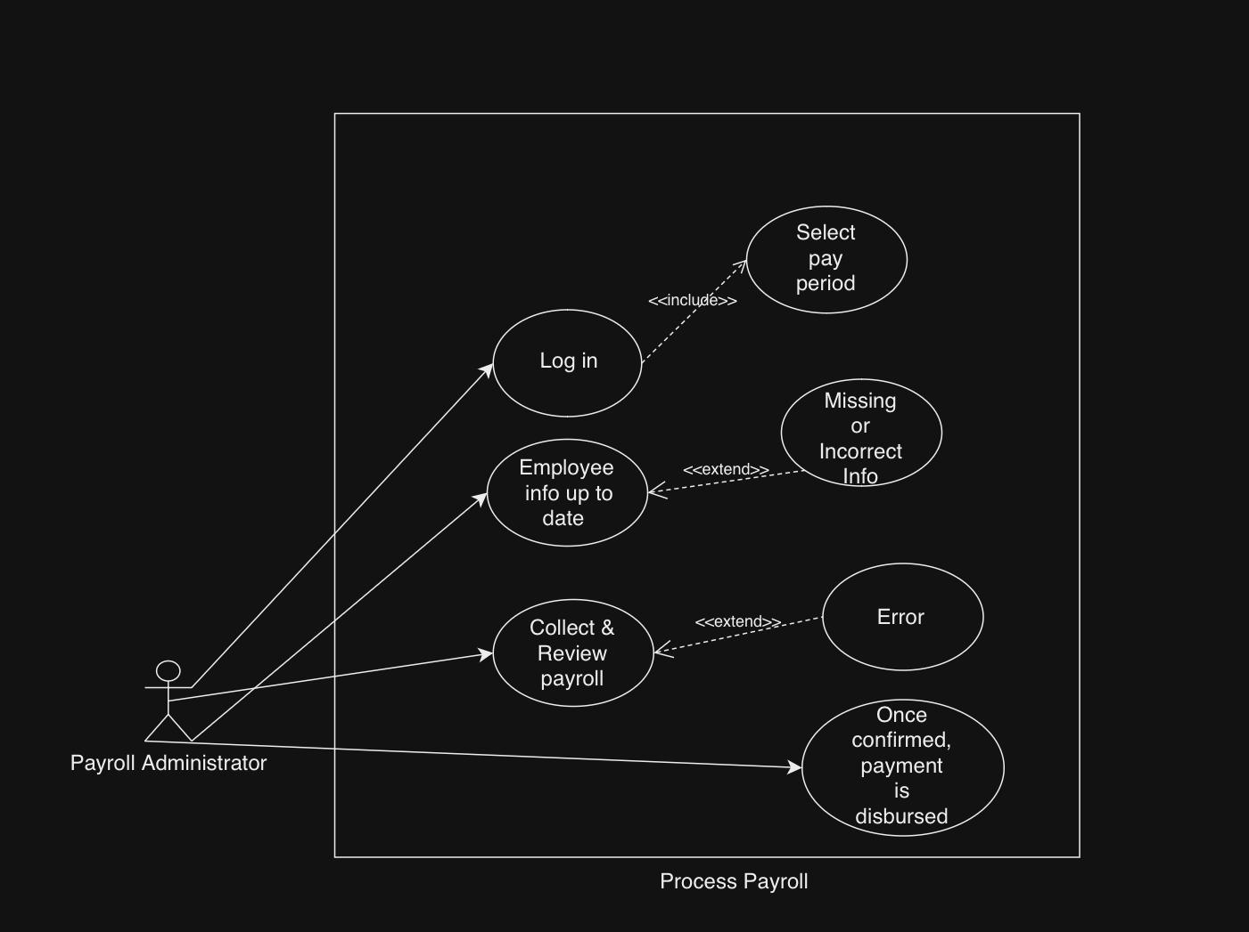

### Use Case 2: Add Employee

|  |  |
| --- | --- |
| **Use Case ID:** | UC-02 |
| **Use Case Name:** | Add Employee |
| **Actor:** | HR Manager |
| **Description:** | This use case covers the addition of a new employee to the system. |
| **Preconditions:** | * HR Manager is logged in. * Necessary employee information is available. |
| **Post Conditions:** | New employee's data is added to the system |
| **Priority:** | Medium |
| **Frequency of Use:** | As needed |
| **Normal Course of Events:** | * HR Manager logs in. * Select the option to add a new employee. * Enter employee details. * The system validates the information. * The system adds the new employee to the database. |
| **Alternative Courses:** | None |
| **Exception:** | * Step 4: If the information is incomplete or contains errors, the system prompts the HR Manager to correct it. |
| **Includes:** | None |
| **Special Requirements:** | None |
| **Assumptions:** | * HR Manager has access to accurate employee information. |

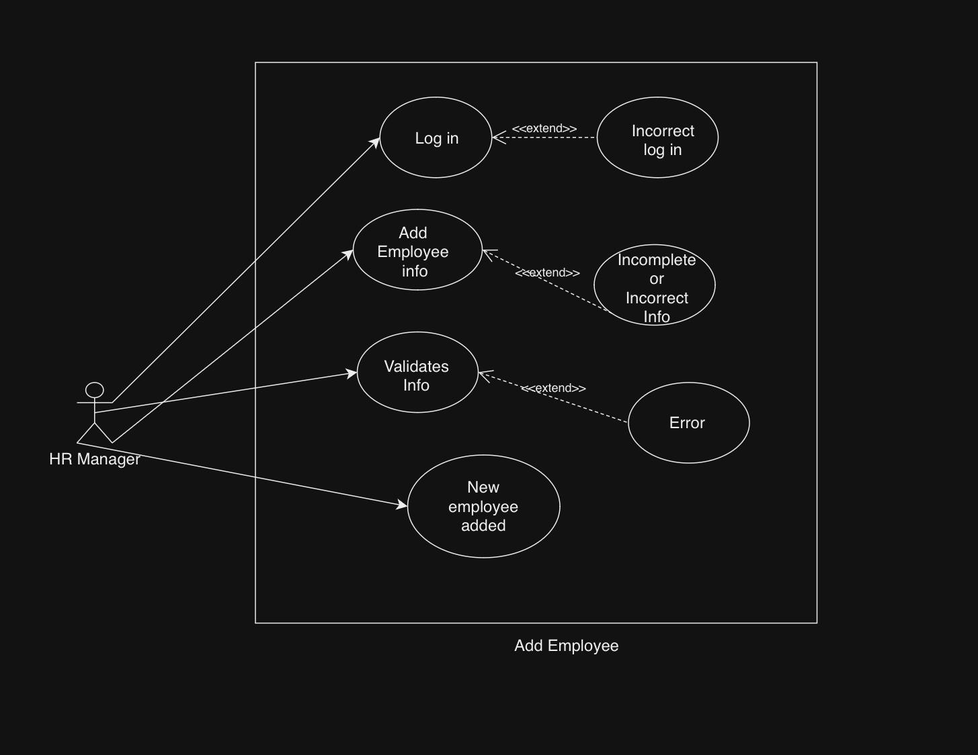

### Use Case 3: Generate Payroll Report

|  |  |
| --- | --- |
| **Use Case ID:** | UC-03 |
| **Use Case Name:** | Generate Payroll Report |
| **Actor:** | Payroll Administrator |
| **Description:** | This use case involves generating payroll reports for accounting and record-keeping purposes. |
| **Preconditions:** | Payroll data is processed and stored. |
| **Post Conditions:** | Payroll report is generated and saved. |
| **Priority:** | Medium |
| **Frequency of Use:** | Monthly |
| **Normal Course of Events:** | * Payroll administrator logs in. * Select the desired pay period. * Generates the payroll report. * Saves the report to the specified location. |
| **Alternative Courses:** | None |
| **Exception:** | None |
| **Includes:** | None |
| **Special Requirements:** | Access to report templates. |
| **Assumptions:** | Payroll data is accurate and up-to-date. |

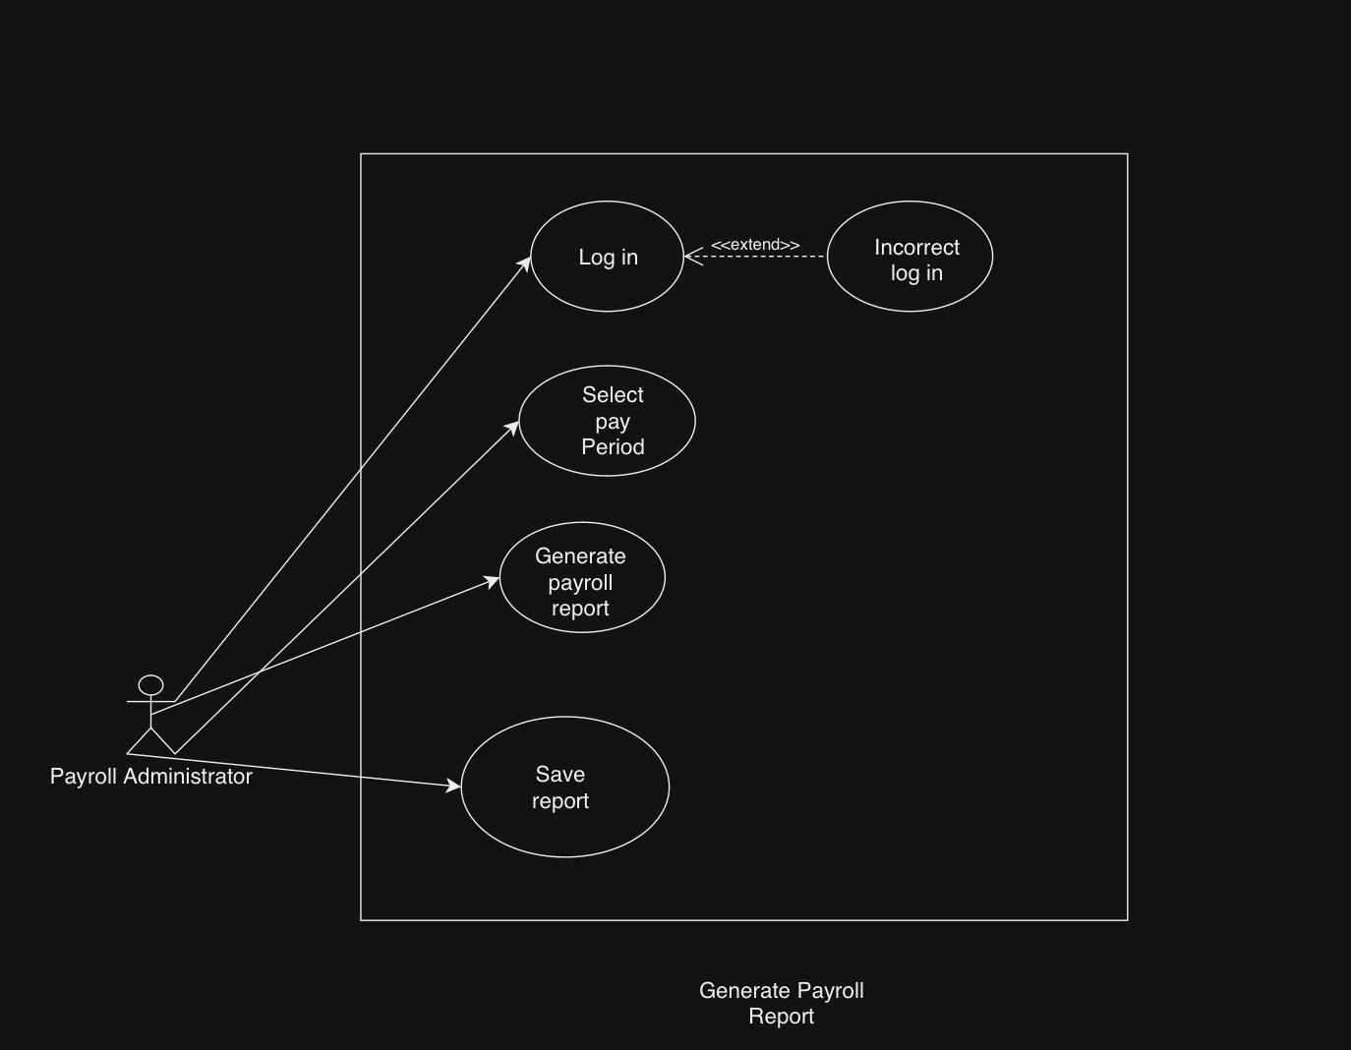

### Use Case 4: Deductions and Benefits Calculation

|  |  |
| --- | --- |
| **Use Case ID:** | UC-04 |
| **Use Case Name:** | Deductions and Benefits Calculation |
| **Actor:** | Payroll Administrator |
| **Description:** | This use case represents the process of calculating and managing employee deductions and benefits. |
| **Preconditions:** | * Payroll data is processed and stored. * Deductions and benefits information is up-to-date. |
| **Post Conditions:** | Deductions and benefits are applied to employee salaries. |
| **Priority:** | High |
| **Frequency of Use:** | Biweekly or Monthly |
| **Normal Course of Events:** | * Payroll administrator logs in. * Select the pay period. * Calculates and applies deductions and benefits. * Updates employee salaries with the changes. |
| **Alternative Courses:** | Step 3: If there are errors in calculation, the administrator can make corrections. |
| **Exception:** | None |
| **Includes:** | None |
| **Special Requirements:** | Accurate deductions and benefits data. |
| **Assumptions:** | Payroll data and deductions/benefits information are accurate and up-to-date. |

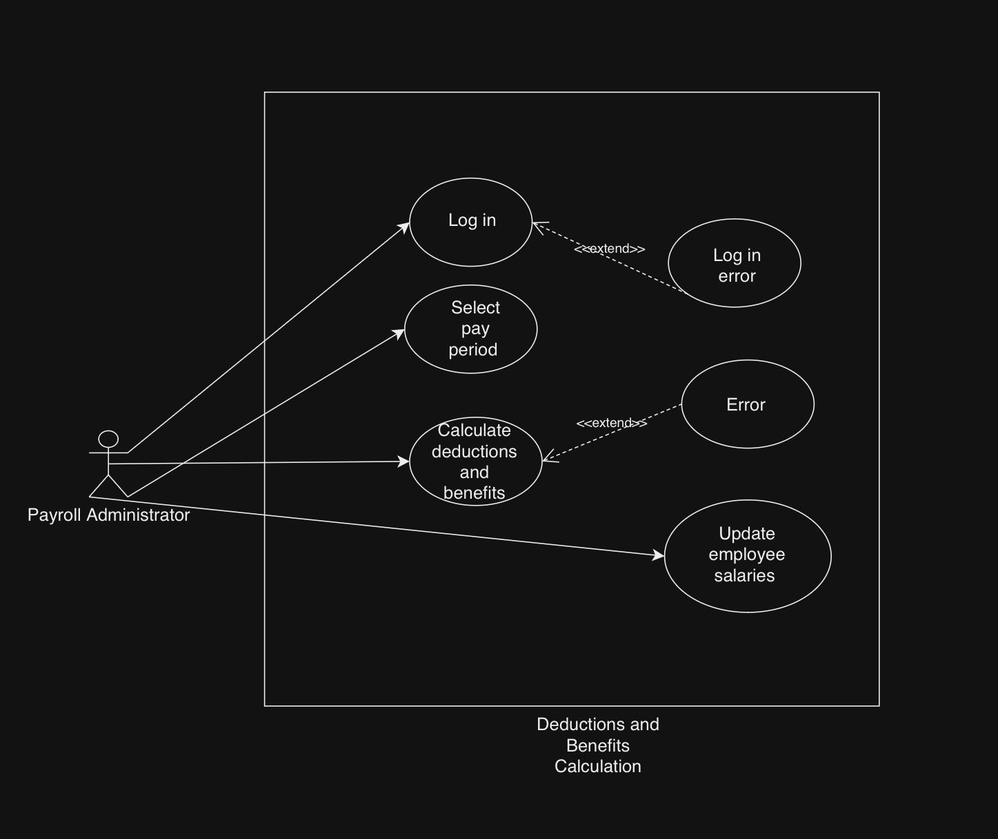

### Use Case 5: Employee Self-Service

|  |  |
| --- | --- |
| **Use Case ID:** | UC-05 |
| **Use Case Name:** | Employee Self-Service |
| **Actor:** | Employee |
| **Description:** | This use case allows employees to access and manage their payroll-related information, such as pay stubs, tax forms, and direct deposit settings. |
| **Preconditions:** | * Employees have access to the self-service portal. * Employees are logged in. |
| **Post Conditions:** | * Employees can view and update their payroll information. |
| **Priority:** | Medium |
| **Frequency of Use:** | Weekly or as needed |
| **Normal Course of Events:** | * Employee logs in to the self-service portal. * Accesses their pay stubs, tax forms, and direct deposit settings. * Make updates if necessary (e.g., changing bank account details). * Logs out when finished. |
| **Alternative Courses:** | None |
| **Exception:** | None |
| **Includes:** | None |
| **Special Requirements:** | Secure self-service portal with authentication. |
| **Assumptions:** | Employees have accurate login credentials. |

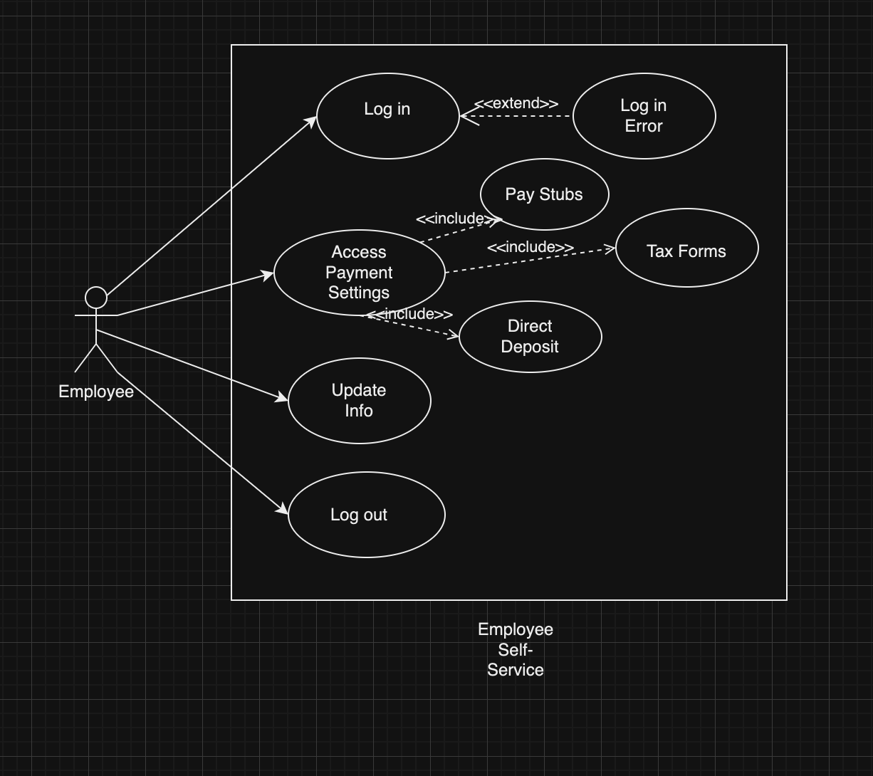

### Use Case 6: Overtime Approval

|  |  |
| --- | --- |
| **Use Case ID:** | UC-06 |
| **Use Case Name:** | Overtime Approval |
| **Actor:** | Manager |
| **Description:** | This use case represents the approval process for employee overtime hours |
| **Preconditions:** | * Overtime requests are submitted by employees. * Managers are logged in. |
| **Post Conditions:** | Overtime requests are either approved or denied. |
| **Priority:** | High |
| **Frequency of Use:** | As needed |
| **Normal Course of Events:** | * Manager logs in. * Views pending overtime requests. * Approves or denies requests. * The system notifies the employees of the decision. |
| **Alternative Courses:** | None |
| **Exception:** | None |
| **Includes:** | None |
| **Special Requirements:** | Integration with employee scheduling systems. |
| **Assumptions:** | Overtime requests are submitted by employees accurately. |

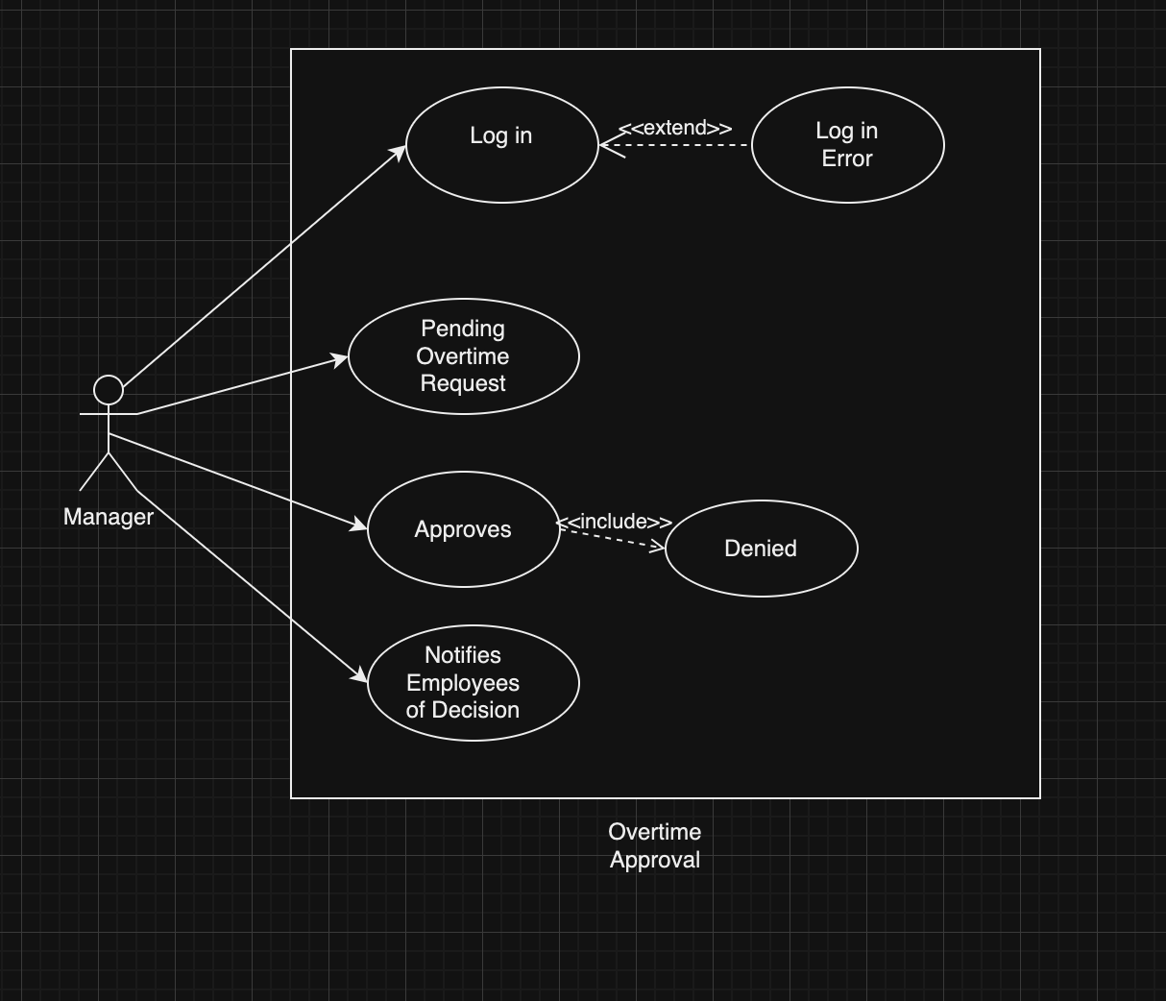

# **Document Used/Referenced**

1. Why digital technology should be at the heart of your payroll solution by ADP

Link: <https://sg.adp.com/resources/articles-and-insights/articles/w/why-digital-technology-should-be-at-the-heart-of-your-payroll-solution.aspx>

1. Payroll Software—What It Is And 10 Key Benefits by Brandy Bischoff

Link: <https://peoplemanagingpeople.com/articles/what-is-payroll-software/>

1. Payroll Management System: What Is It For And How Does It Benefit Your Organization? By Asha J.

Link: <https://elearningindustry.com/payroll-management-system-what-is-it-for-and-how-does-it-benefit-your-organization>

1. Manual Data Entry: Challenges and solutions in 2023 by Neha Gunnoo

Link: <https://parseur.com/blog/manual-data-entry>

1. 5 Things Law Firms Need from Their Payroll Software by Workful

Link: <https://blog.workful.com/blog/law-firms-payroll-software/>

1. The 7 Most Common Payroll Errors (And How to Avoid Them) by FuseWorkForce

Link: <https://www.fuseworkforce.com/blog/the-7-most-common-payroll-errors-and-how-to-avoid-them>

1. The Dangers of Doing Payroll by Hand and How to Avoid Them by Kaylee Dewitt

Link: <https://www.patriotsoftware.com/blog/payroll/doing-payroll-by-hand/>

1. Cloud Software Development: Everything You Need to Know By Cordenne Brewster Link: <https://www.trio.dev/blog/cloud-software-development>
2. Software Project Team Roles and Responsibilities by Sherrie Rose

Link: <https://sherrierose.medium.com/software-project-team-roles-and-responsibilities-152a7d575759>

1. Who are the key influencers or stakeholders? By Indeed Editorial Team

Link: <https://www.indeed.com/career-advice/career-development/questions-to-ask-before-starting-project>

1. Who are the key influencers or stakeholders? By Dino Cajic

Link: <https://medium.com/geekculture/role-of-a-project-manager-in-software-development-777e178a0a9a>

1. What is payroll software? By Oracle

Link: <https://www.oracle.com/human-capital-management/payroll/what-is-payroll-software/>

### 